**Microsoft Excel: PowerPivot**

### **Session 5.4: Microsoft Excel**

This document is a quick reference guide for reviewing the techniques in the laboratory.

For these exercises, download the files:

“Business Analytics – Week 5 Instructions.doc”

“Business Analytics – Week 5 Orders NoRelationships Database.acc”

**PowerPivot Add-in**

PowerPivot is an add-in to Excel. To add the capability:

1. Open Excel
2. Go to **File** > **Options** > **Add-Ins**
3. In the **Manage** box, click **COM Add-ins**, then **Go**.
4. Check the **Microsoft Office Power Pivot in Microsoft Excel 2013** box, then click **OK**

**Session 5.5: Getting Started & Importing Data**

We want to launch PowerPivot and import data from other sources.

1. Click on the PowerPivot tab at the top of the screen
2. Click on Manage in the upper left corner

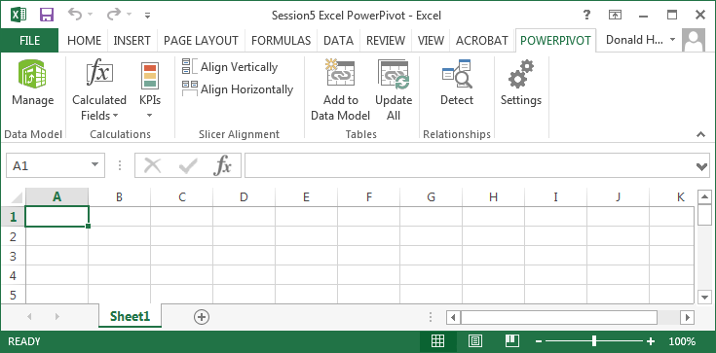

1. Click on Get External Data, then Database, then From Access

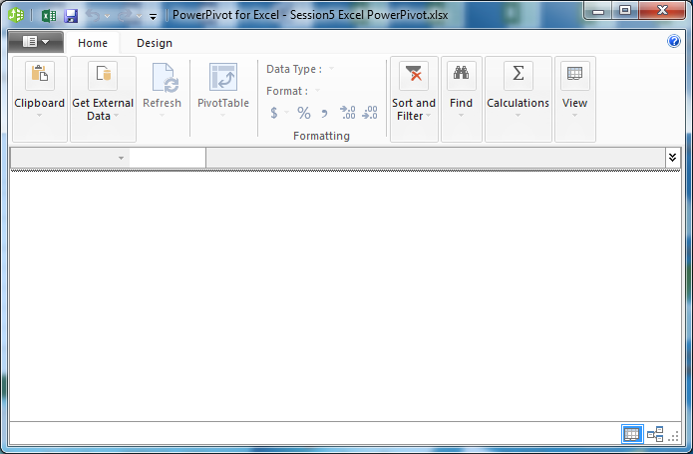

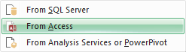

1. Click on Browse, and find the Business Analytics – Week 5 Orders NoRelationships Database downloaded from the website; click Next

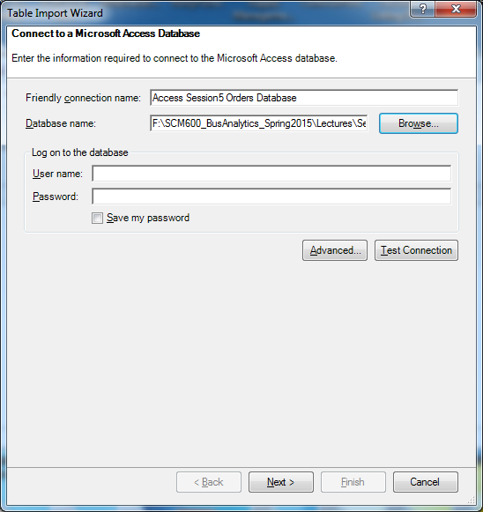

1. Select the default “Select from a list of tables”, then click Next

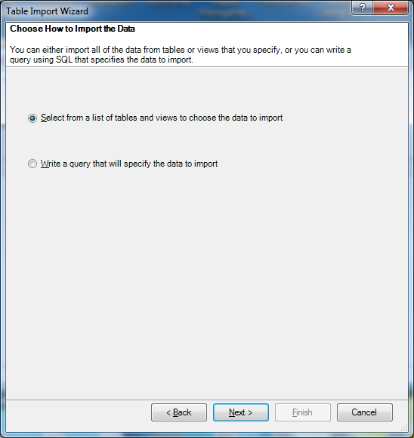

1. Check the box for tables Categories through Suppliers, then Finish

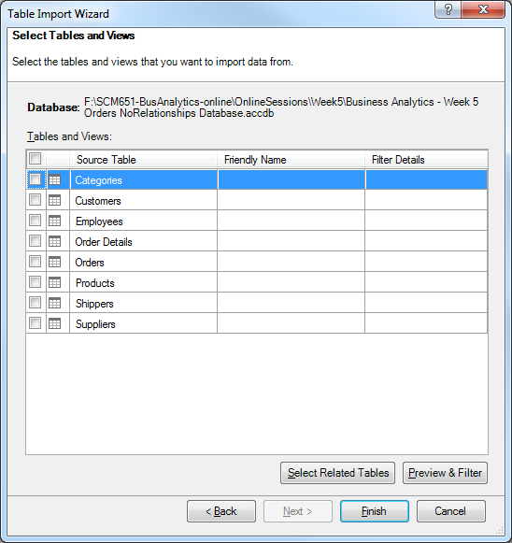

1. The completed import will list the tables and number of rows transferred; click Close.

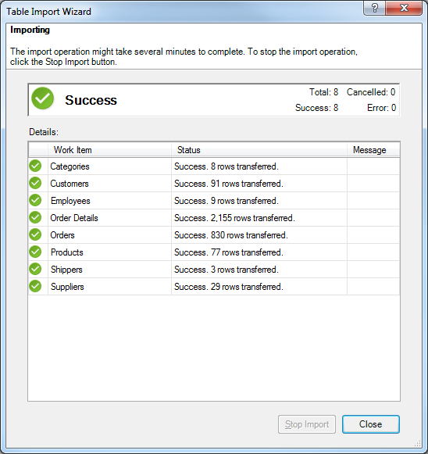

1. The data grid should appear. The tabs at the bottom include all of the tables.

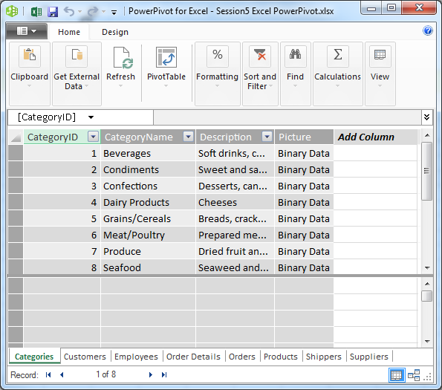

**Session 5.6: Relationships**

In Microsoft Access, we were able to establish relationships between tables. We can create similar relationships in Excel PowerPivot.

1. In the lower right corner of the Data Grid, click on the diagram view. Notice that there is a scroll bar; you can scroll to see all the tables.

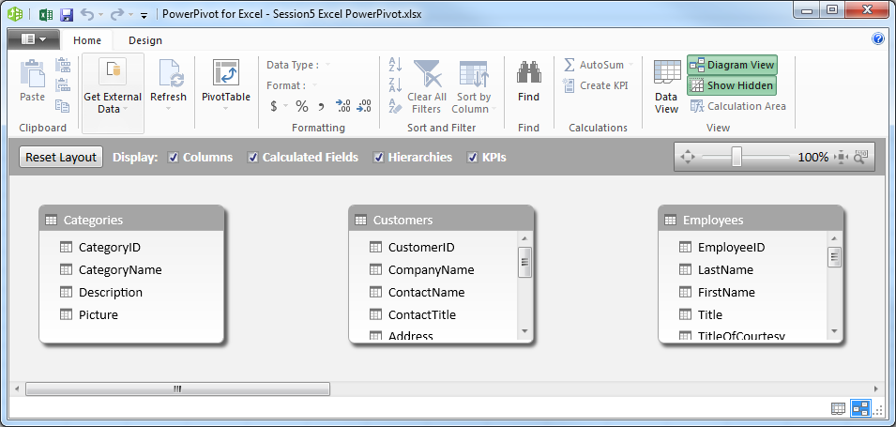

1. I’ve reorganized the tables so it’s easier to see the data

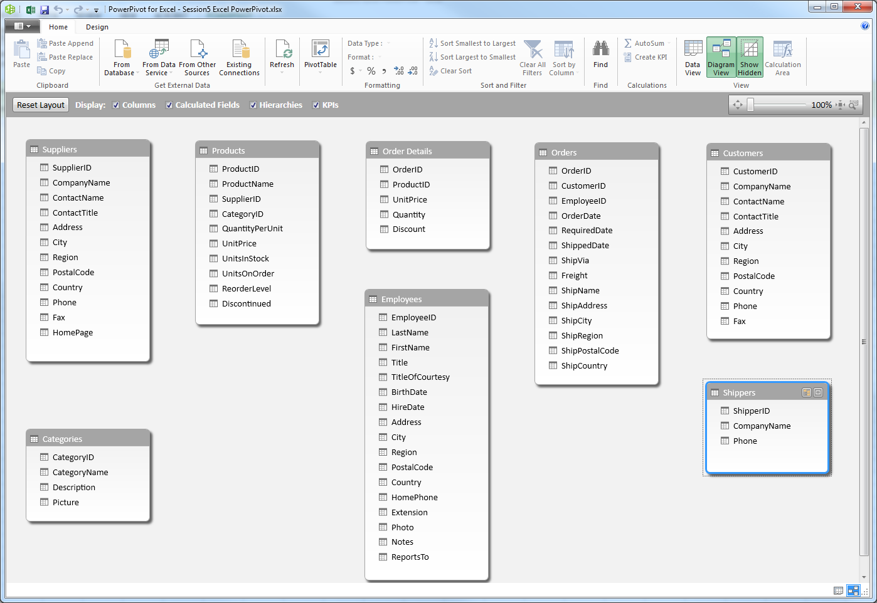

1. Now, create relationships by dragging and dropping the unique field in one table that is in common with another.
   1. Suppliers table: SupplierID with Products table: SupplierID
   2. Categories table: CategoryID with Products table: CategoryID
   3. Products table: ProductID with OrderDetails table: ProductID
   4. OrderDetails table: OrderID with Orders table: OrderID
   5. Orders table: EmployeeID with Employee table: EmployeeID
   6. Orders table: CustomerID with Customers table: CustomerID
   7. Orders table: ShipVia with Shippers table: ShipperID (Note: the fields used in establishing the relationship can have different names, as long as they have the same data)
2. When you are done, click on any relationship. It will show the two tables connected and the field names used for the relationship.

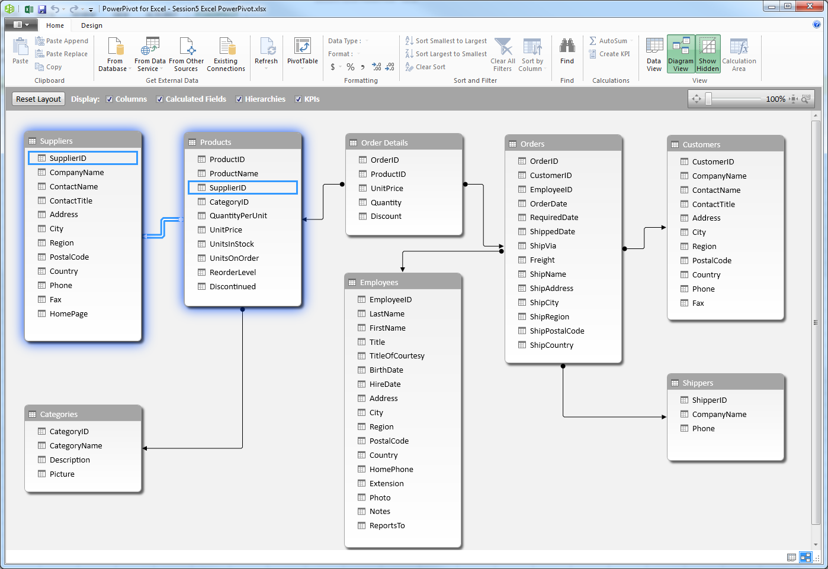

1. Save your work by clicking on the icon in the upper left, and saving.
2. In the upper right of the screen, switch back to the Data View.
3. If you close this view, you can always come back by clicking Manage.

**Session 5.7: Table Properties**

Table properties presents additional information on the source of your data, data display, and filters.

1. In PowerPivot, click on the Design tab in the upper left corner
2. Click on the title of the Suppliers table (it should highlight the table)
3. Click on Table Properties at the top of the screen
4. Notice that the Connection Name identifies where the data originated

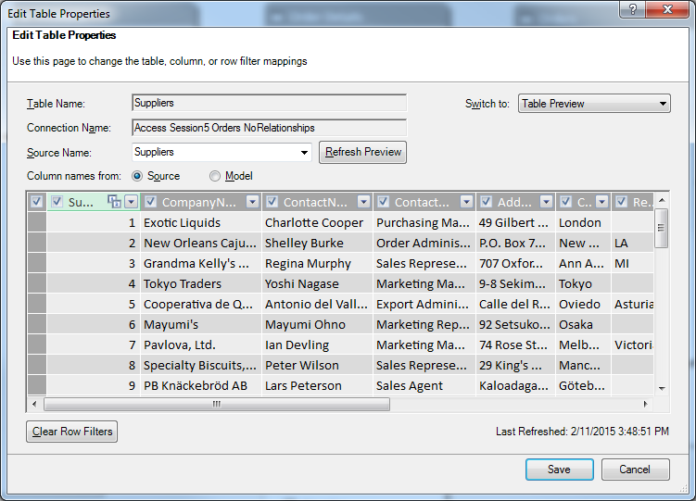

**Table Filters**

Filters are also possible in this view.

1. Click on the down arrow for Company Name
2. Click on the box before (Select All) to uncheck the box
3. Check the box for Bigfoot Breweries, then OK

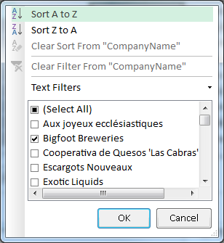

You should see the following filtered data.

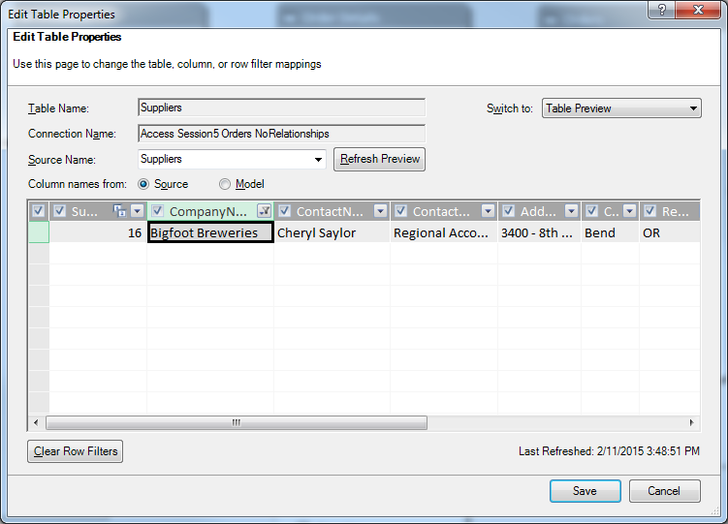

In the upper right of the view, click on the “Switch to:” drop down menu and change from Table Preview to Query Editor. It now displays the SQL to implement this filter.

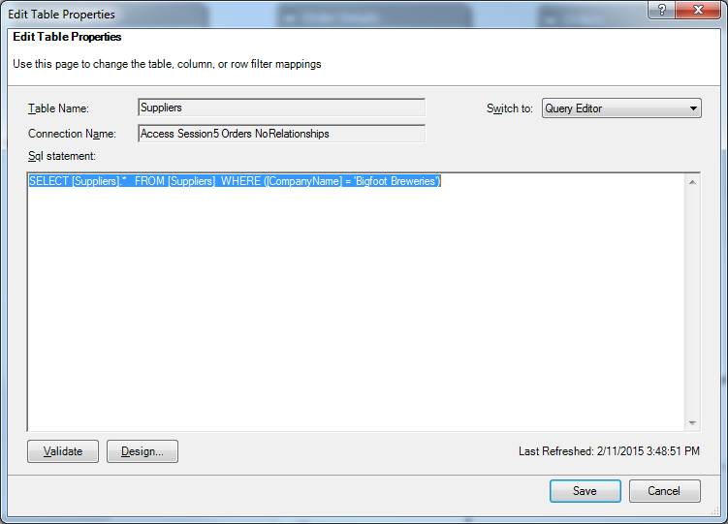

Change back Switch to: Table Preview, then change the filter to Select All.

**Refreshing Data**

In the earlier description of Table Properties, we saw that there was an active connection to our original database. What happens if your database is updated? You don’t need to re-import the data, just use the refresh option.

1. In the PowerPivot screen, click on the Home tab in the upper left corner
2. At the top of the screen is Refresh button. Hover over the button and it says: “Refresh the data that was imported from external data sources”
3. Click on the Suppliers table to highlight it.
4. Click on the down arrow below the refresh button.
5. Click on Refresh. PowerPivot goes to the Access database, retrieves the Suppliers data, and updates your table.
6. Similarly, try Refresh All.

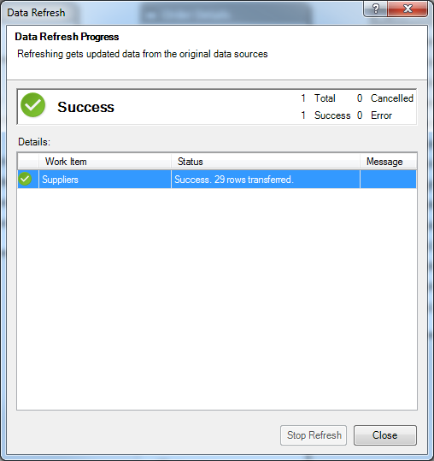

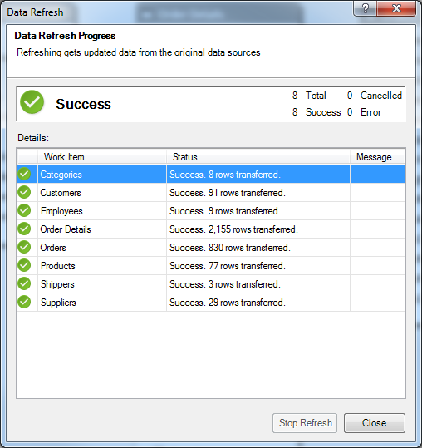

**Session 5.8: Creating Pivot Tables with PowerPivot**

Let’s now create Pivot Tables, incorporating data across multiple tables.

1. In PowerPivot, click on the Home tab in the upper left corner
2. At the top of the screen, click on the drop down arrow below PivotTable and select Pivot Table
3. Select New Worksheet, then OK

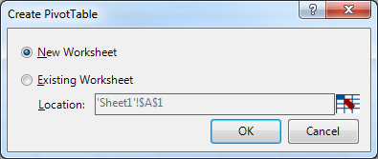

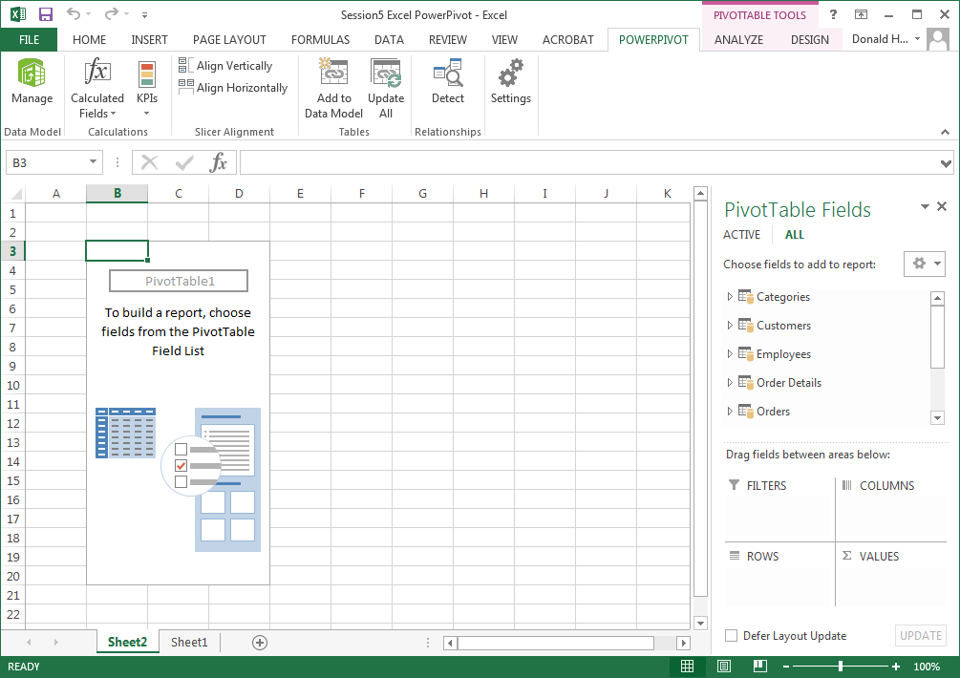

1. Notice that in the upper right of the pivot table, it lists PivotTable Fields. In this case, we now have all of the tables, not just one table.
2. Let’s build a Pivot Table with the total quantity ordered for each category of products. Which table has CategoryName? Which table has Quantity (ordered)?
3. Click on the arrow next to the table Categories. Click on CategoryName and drag to Rows.
4. Scroll down in the PivotTable Fields until you see Order Details, then click on the arrow next to the table Order Details. Click on Quantity and drag it to Values.
5. You should see the view below.

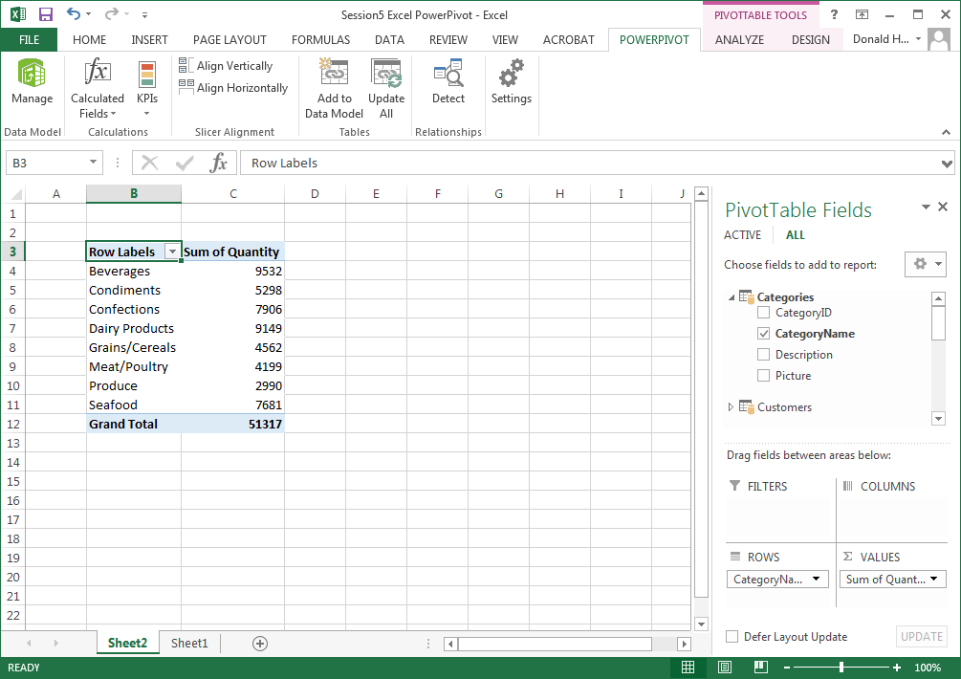

**Session 5.9: Slicers**

Let’s dive deeper and examine quantity ordered by category and by a customer’s country. A Slicer allows you to select data in varying “slices”.

1. First, find where a customer’s country is stored. It’s in the table Customers, in the field Country.
2. In the PivotTable screen, look for PivotTable Tools in the upper right corner of the screen. Click on Analyze.
3. In the top middle of the screen, click on Insert Slicer
4. The Active tables are the ones we have used so far. But Country is stored in the Customers table. Click on ALL to see all tables, then check the box for Country in the Customers table. Click OK.

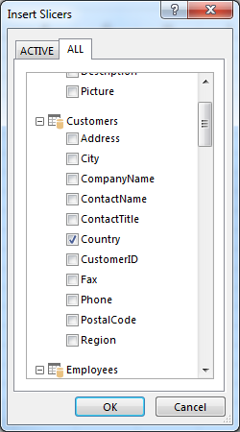

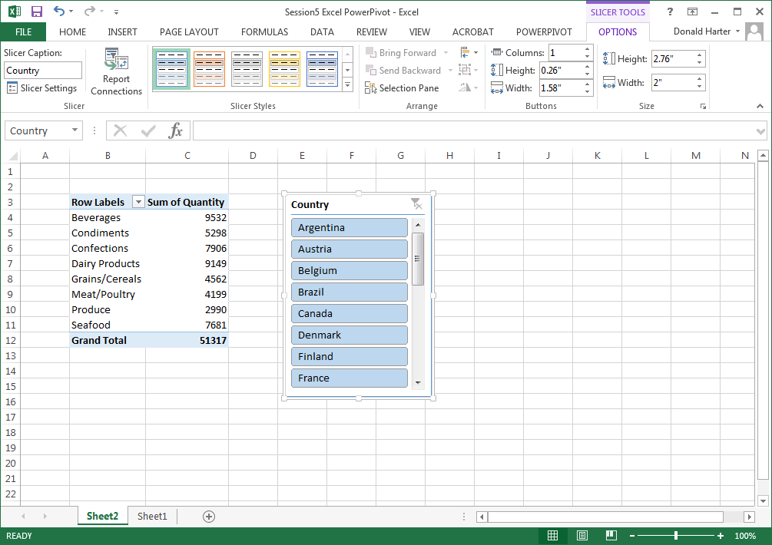

1. Notice that all countries are highlighted. Click on Argentina and watch how the numbers change.
2. To select more than one country, hold down the Control (Ctrl) key and select multiple countries. Select Argentina and Austria.
3. To return to the entire list, click on the funnel picture (filter picture) in the upper right corner of the slicer.

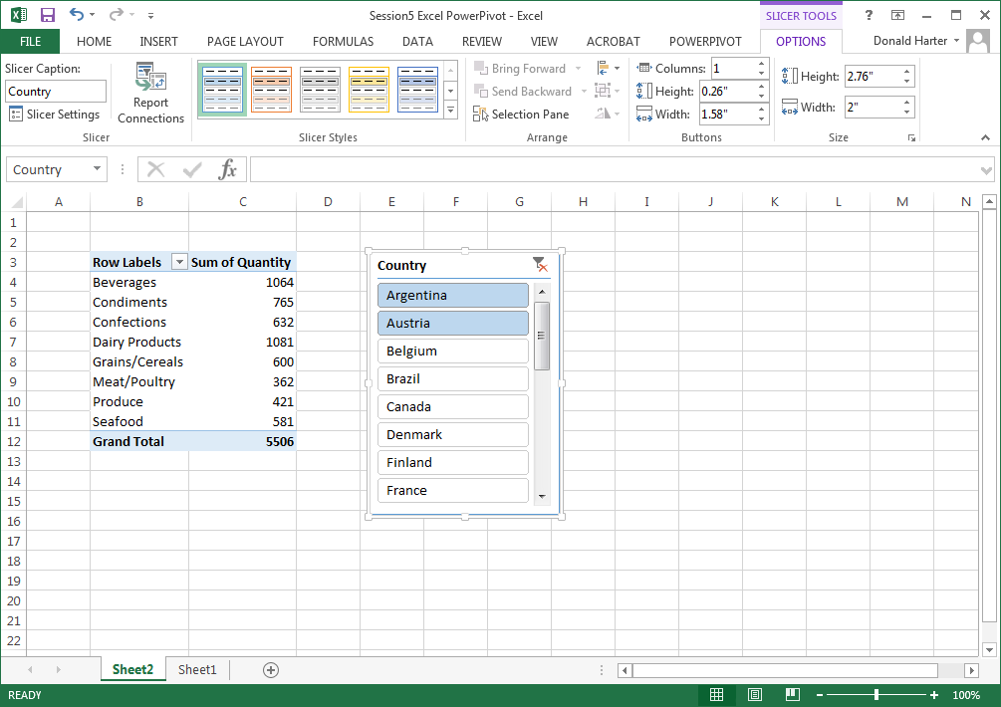

1. To remove the slicer, right click on the slicer and click on Remove “Country”

**Session 5.10: Timelines**

A useful technique for filtering data by dates is the Timeline option.

1. In the PivotTable Tools, Analyze tab, click on Insert Timeline
2. Click on the All tab and check the box for OrderDate in the Orders table, then OK
3. Notice that all dates are highlighted in blue. Click on January 1995 to highlight only that month
4. You can select multiple months by holding down the control key can clicking on multiple months.
5. Click on the filter in the upper right corner of the Timeline screen to bring back all data.
6. Right click on the Timeline and click Remove Timeline

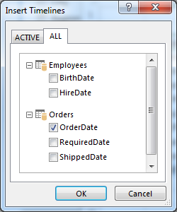

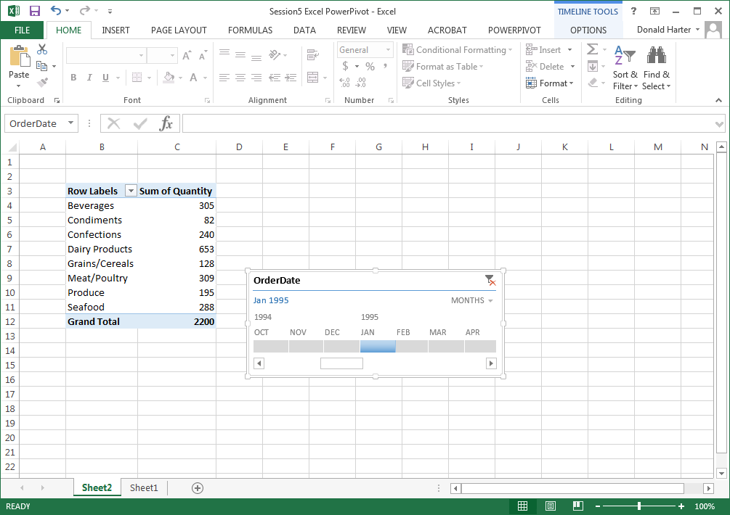

**Session 5.11: Pivot Charts**

Pivot charts can also be created in Power Pivot.

1. Click on PivotTable Tools, Analyze
2. Click on Field List to pop up the field list on the right side of the screen
3. Click on the arrow next to Shippers, check the CompanyName box, and drag it to Columns

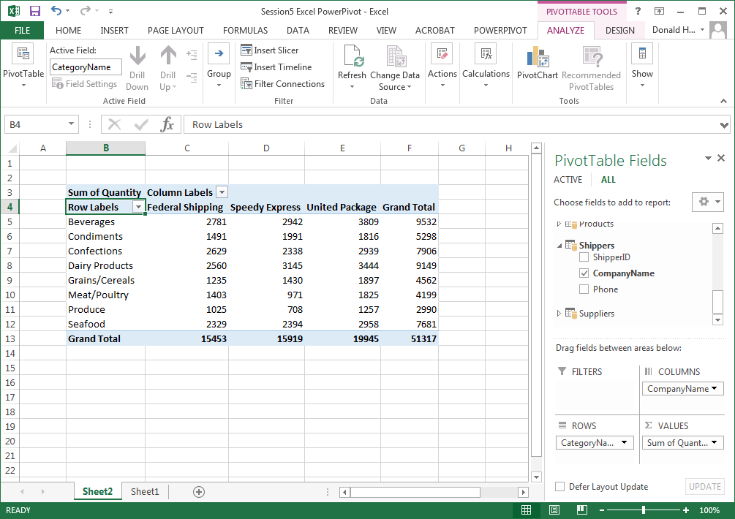

1. Next, click on PivotChart in the upper right corner of the screen
2. Select my favorite, 3-D Column, then OK

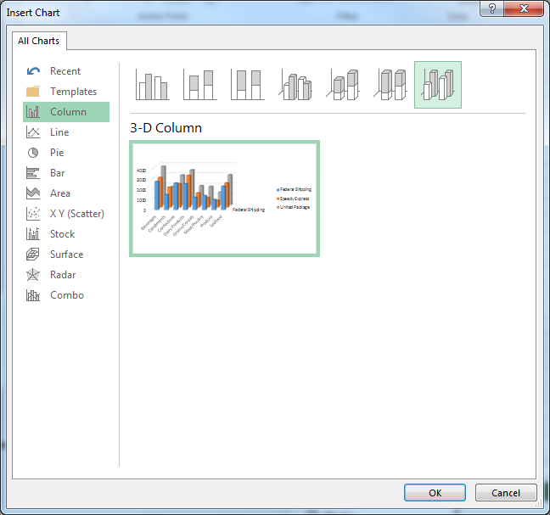

1. Right click on the chart, select Move Chart, then check the button for New Sheet

